Mikro 2
Eksamen 2019

1)
a) normal form in matrix representation:
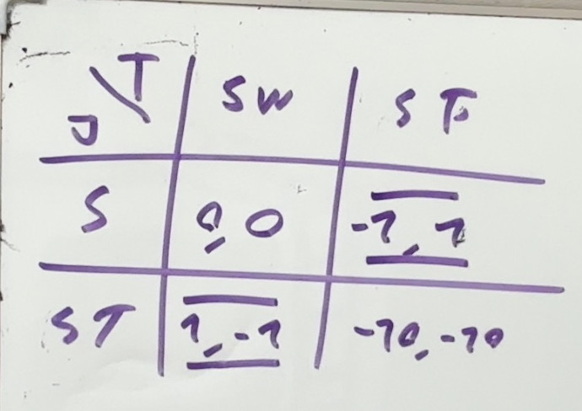
Here ive used the best responce method to find 2 NE
Now we need to see if there is one in mixed strategies
We do this with the indiffrence trick:
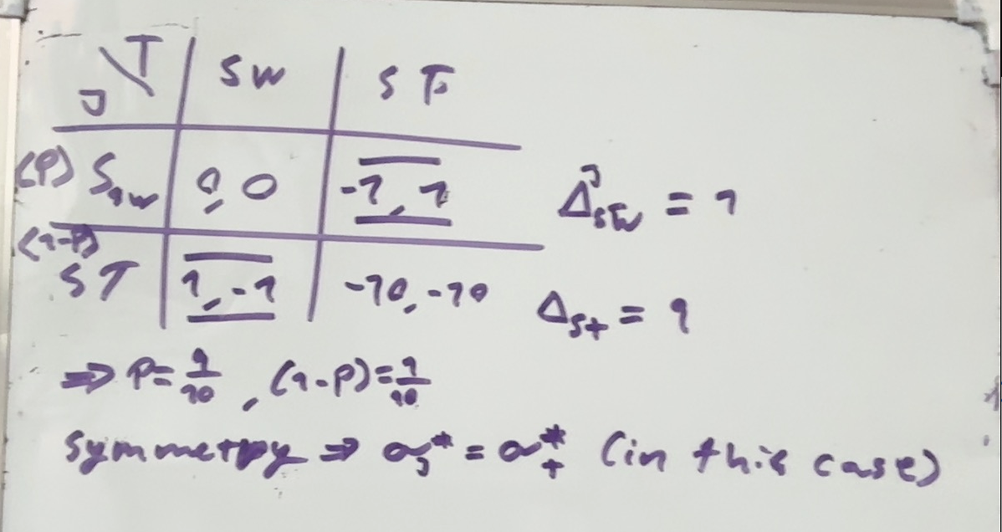

Thus we have 3 NE
$$NE=\left\{\left(ST,SW\right),\left(SW,ST\right),\left(\left(\frac{9}{10},\frac{1}{10}\right),\left(\frac{9}{10},\frac{1}{10}\right)\right)\right\}$$

$$with \left(\frac{9}{10},\frac{1}{10}\right)=\left(P\left(A_{i}=SW\right),P\left(A_{i}=ST\right)\right)$$
b) im assuming that this implies that tom can no loger swerve
b1)
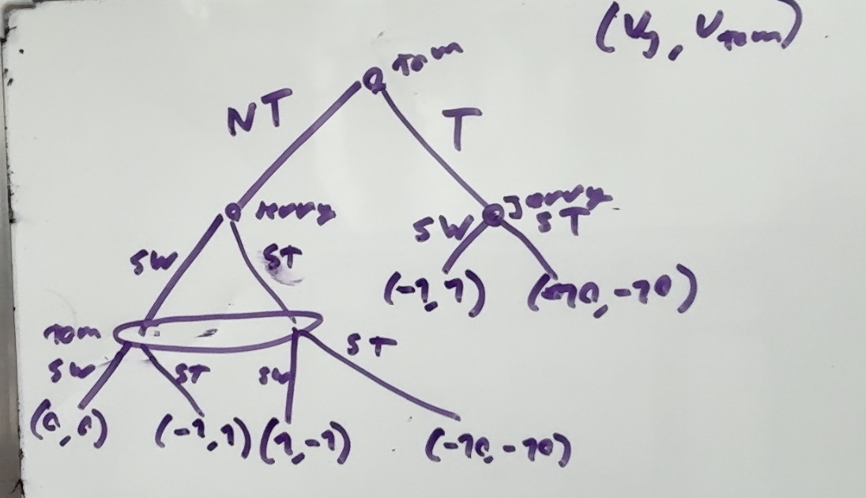

b2)
jerry: has 4 different strategies since he has 2 options in each informationset
$$\left(SW,SW\right),\left(SW,ST\right),\left(ST,SW\right),\left(ST,ST\right)$$
Tom also has 4(since his strategy needs to be defined off path)
$$\left(T,SW\right),\left(T,ST\right),\left(NT,SW\right),\left(NT,ST\right)$$

b3)
there are 2 subgame perfect NE
The true route we must have jerry choosing SW since this action is then strictly dominant
In the NT route we must have one of the pure strategy NE from (a)
$$\left(SW,ST\right) or \left(ST,SW\right)$$
Then we have this drawing with possible EQ paths
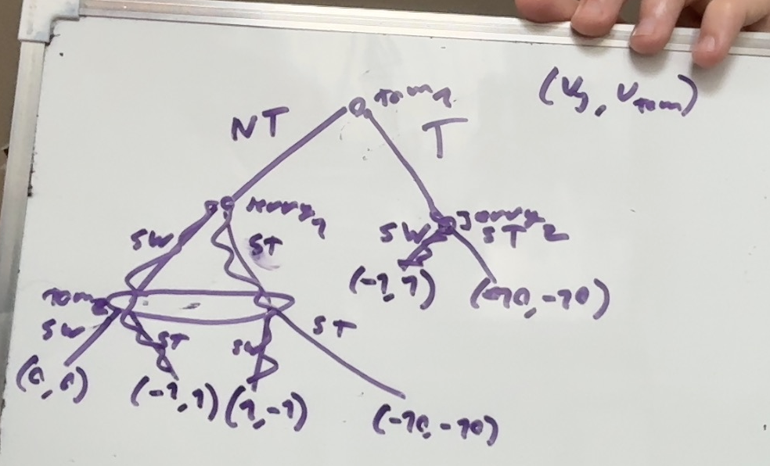
Note the small numberrings of each action (jerry_1,jerry_2)

For a strategy to be subgame perfect we must have NE in all subgames also the one with the whole game:
For T
Jerry gets utility 1 and thus will never have incentive to deviate thus both NE in the NT path work
Thus
$$\{\left(\left(T,SW\right),\left(ST,SW\right)\right),\left(\left(T,ST\right),\left(SW,SW\right)\right)\}$$
Are both SPNE
Now we inspect for $NT$
The NT path must be one of the 2 and give Tom utility at least 1 thus the only one that is viable is
$$\left\{\left(\left(NT,ST\right),\left(SW,SW\right)\right)\right\}$$

The SPNE are
$$\left\{\left(\left(T,SW\right),\left(ST,SW\right)\right),\left(\left(T,ST\right),\left(SW,SW\right)\right),\left(\left(NT,ST\right),\left(SW,SW\right)\right)\right\}$$

Actions are in the notation $\left(tom_{1},tom_{2}\right),\left(jerry_{1},jerry_{2}\right)$
b4)
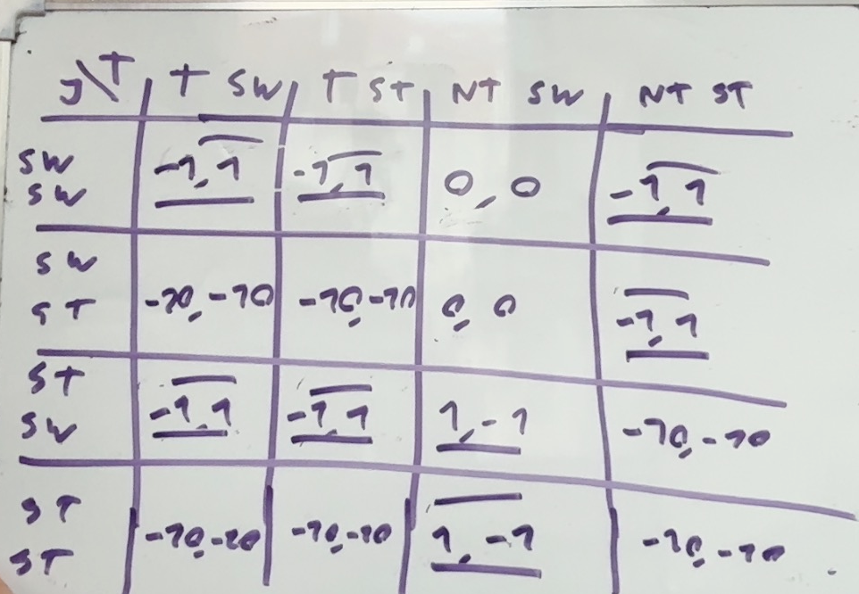

Ive done the best responce method on the game such that we can simply choose one which is a NE but not subgame perfect

One could be $\left(\left(T,SW\right),\left(SW,SW\right)\right)$
This is not subgame perfect as when of EQ path particularly down
The NT route the strategiy profile
$$\left(SW,SW\right) is not a NE for the normal form game from (a)$$
b5)
there are 3 which give tom a payoff of 1
all the one described before
$$\left\{\left(\left(T,SW\right),\left(ST,SW\right)\right),\left(\left(T,ST\right),\left(SW,SW\right)\right),\left(\left(NT,ST\right),\left(SW,SW\right)\right)\right\}$$

Tom should prefer to throw the wheel as this forces jerry to swerve

2)
a) we find NE:
as L strictly dominates R and U strictly dominates D
rational players will only play $(U,L)$

b) we know that in every round the players will play $\left(U,L\right)$
its a result since $G$ has a unique NE it must be played in every round of $G^{n}$

also we can argue that all collaberation breaks

in round n the only rational play is $(U,L)$ since there are no consequences

in round $n-1$ the players know the outcome that must occur in game n meaning there is no consequences thus they play $(U,L)$

this argument holds all the way to the first game meaning the game will always have $(U,L)$ played

c)
we have to choose what to play in the beginning and then what to play dependent on the other players action then multiply the possibilities

we have
$$\left(U\left|L,U\right|R\right),\left(D\left|L,U\right|R\right),\left(U\left|L,D\right|R\right),\left(D\left|L,D\right|R\right)$$
Thus 4 dependent
$$4·2=8$$
Thus 8 possible strategies for each player
d)
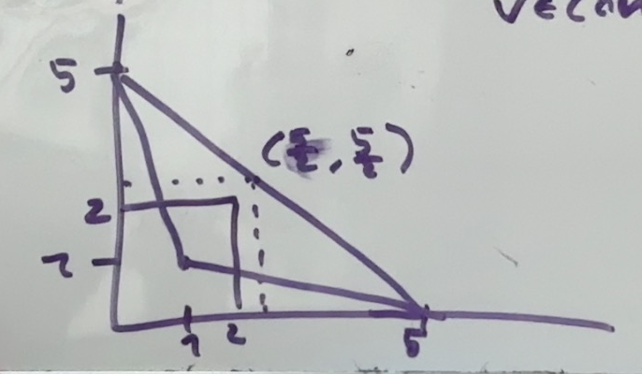
$$V feasible⇔V∈conv\left(\left(\begin{aligned}1 \\ 1\end{aligned}\right),\left(\begin{aligned}5 \\ 0\end{aligned}\right),\left(\begin{aligned}0 \\ 5\end{aligned}\right)\right)$$
$$\left(\begin{aligned}2.5 \\ 2.5\end{aligned}\right)=\frac{1}{2}·\left(\left(\begin{aligned}5 \\ 0\end{aligned}\right)+\left(\begin{aligned}0 \\ 5\end{aligned}\right)\right)$$
$$α·\left(\begin{aligned}1 \\ 1\end{aligned}\right)+\left(1-α\right)·\left(\begin{aligned}2.5 \\ 2.5\end{aligned}\right)=\left(\begin{aligned}2 \\ 2\end{aligned}\right)$$
$$⇔α+2.5·\left(1-α\right)=2$$
$$⇔\frac{5}{2}-\frac{3}{2}α=2$$
$$⇔3α=1$$
$$⇔α=\frac{1}{3}$$

Thus
$$\frac{1}{3}·\left(\begin{aligned}1 \\ 1\end{aligned}\right)+\frac{2}{3}\left(\frac{1}{2}·\left(\left(\begin{aligned}5 \\ 0\end{aligned}\right)+\left(\begin{aligned}0 \\ 5\end{aligned}\right)\right)\right)=\left(\begin{matrix}2 \\ 2\end{matrix}\right)$$
e)
an outcome path netting each player 2.5 per game on average would be them alternating between getting 5 each every round thue each player

player 1 plays: $\left(U,D,U,D,…\right)$
player 2 plays: $(R,L,R,L,…)$

f)
player 1:$s_{1}^{n}=\left\{\begin{aligned}U|s_{2}^{n-1}=L GT|s_{2}^{n-1}=R for n even \\ U\left|s_{2}^{n-1}=R GT\right|s_{2}^{n-1}=L for n uneven \end{aligned}\right.$
player 2: $s_{2}^{n}=\left\{\begin{aligned}R|s_{2}^{n-1}=D GT|s_{2}^{n-1}=U for n even \\ L\left|s_{2}^{n-1}=U GT\right|s_{2}^{n-1}=D for n uneven \end{aligned}\right.$
GT means that the player simply plays $U for player 1 and L for player 2$ for the remaining games
We check the 1 step deviation principle
I only check for 1 player the other holds by symmetri

If a player will want to deviate it will always be in the 1. round/rotation otherwise the gain will simply be diluted
a player will only want to deviate when playing his strictly dominated strategy otherwise he will simply throw away payoff
we check player 2 and evaluate the payoff of deviating vs not
$$V_{2}^{deviation}=1+δ·\sum_{i=0}^{∞}{δ^{i}}=1+\frac{δ}{1-δ}=1+\frac{0.999}{1-0.999}=1000$$

$$V_{2}^{nodeviation}=δ·\sum_{i=0}^{∞}{5·δ^{2i}}=5·\frac{δ}{1-δ^{2}}=\frac{5·0.999}{1-{0.999}^{2}}$$
$$\frac{5·0.999}{1-{0.999}^{2}}≈2498,7493747>1000$$
Player 1 wil simply want to deviate a round later(assuming that he will deviate) and thus by symmetri of payoffs also does not want to deviate
Thus the EQ is a SPNE

g) just thinking about it. An average payoff of 4.5 for player 1 implies a maximum of 0.5 payoff for player 2 but player 2 can get an average payoff of of at least 1 by deviating thus this can never be a SPNE
looking at the graph anything in the triangle right of the original NE can be supported but not this one as player 2 would rather deviate

3)
$$Π\left(q,w\right)=R\left(q\right)-w$$
$$R^{'}\left(q\right)>0,R^{''}\left(q\right)<0$$
$$R\left(0\right)=0$$
$$U\left(w,q,η\right)=w-q·η$$
$$η_{1}>η_{2}>0$$

Its a screening game

a)
$$\max_{w_{1},q_{1},w_{2},q_{2}}\left(1-λ\right)\left(R\left(q_{1}\right)-w_{1}\right)+λ\left(R\left(q_{2}\right)-w_{2}\right)$$
$$s.t$$
$$w_{1}-q_{1}·η_{1}≥0$$
$$w_{2}-q_{2}·η_{2}≥0$$
b)
Assume $w_{i}-q_{i}·η_{i}>0$
Decrease $w by ϵ>0$ increaing profit by $ϵ·\left(1-λ\right)>0 or ϵ·λ>0$
Thus both must be binding
Set up new problem
$$\max_{q_{1},q_{2}}\left(1-λ\right)\left(R\left(q_{1}\right)-η_{1}q_{1}\right)+λ(R\left(q_{2}\right)-q_{2}·η_{2})=E[Π]$$
$$\frac{∂E\left[Π\right]}{∂q_{1}}=\left(1-λ\right)\left(R^{'}\left(q_{1}\right)-η_{1}\right)=0⇔R^{'}\left(q_{1}\right)=η_{1}$$
$$\frac{∂E\left[Π\right]}{∂q_{2}}=λ·\left(R^{'}\left(q_{2}\right)-η_{2}\right)=0⇔R^{'}\left(q_{2}\right)=η_{2}$$
$$w_{2}=q_{2}·η_{2}$$
$$w_{1}=q_{1}·η_{1}$$
c)
$$R^{'}\left(q_{1}\right)=η_{1}>η_{2}=R^{'}\left(q_{2}\right)$$
$$since R^{''}\left(q\right)<0$$
$$⇒q_{1}<q_{2}$$
Thus the worker who has less disutility from producing produces more which makes great intuitive sense

First best contract are generally Pareto effecient
Also the workers have utility 0 and the employer has just maximized his utility under constriction that their utility is 0 thus there is no way to improve ones utilty without another being strictly worse

d)
$$\max_{w_{1},q_{1},w_{2},q_{2}}\left(1-λ\right)\left(R\left(q_{1}\right)-w_{1}\right)+λ\left(R\left(q_{2}\right)-w_{2}\right)$$
$$s.t$$
$$\begin{aligned}w_{1}-q_{1}·η_{1}≥0 \#\left(PC1\right)\end{aligned}$$
$$\begin{aligned}w_{2}-q_{2}·η_{2}≥0\#PC2\end{aligned}$$
$$\begin{aligned}w_{1}-q_{1}·η_{1}≥w_{2}-q_{2}·η_{1}\#IC1\end{aligned}$$
$$\begin{aligned}w_{2}-q_{2}·η_{2}≥w_{1}-q_{1}·η_{2}\#IC2\end{aligned}$$
$$w_{2}-q_{2}·η_{2}≥w_{1}-q_{1}·η_{2}≥w_{1}-q_{1}·η_{1}≥0$$
2. inequality since $η_{1}>η_{2}$ thus PC2 is slack

Note that $IC1,IC2⇒q_{2}≥q_{1}$
PC1 must be binding:
Assume $w_{1}-q_{1}·η_{1}>0$
Since $PC2$ is slack
Decrease $w_{1},w_{2}$ by the same $ϵ>0$ meaning higher utility while all constraints are holding
Thus $PC2$ must bind
$$w_{1}=q_{1}·η_{1}$$
We write up the 2 remaining constraints
$$\begin{aligned}w_{1}-q_{1}η_{1}≥w_{2}-q_{2}·η_{1}\#IC1\end{aligned}$$
$$\begin{aligned}w_{2}-q_{2}·η_{2}≥w_{1}-q_{1}·η_{2}\#IC2\end{aligned}$$

IC2 must bind otherwise decrease $w_{2}$
$$w_{2}-q_{2}·η_{2}=q_{1}·η_{1}-q_{1}·η_{2}⇔w_{2}-w_{1}=q_{2}·η_{2}-q_{1}·η_{2}=η_{2}\left(q_{2}-q_{1}\right)≤η_{1}\left(q_{2}-q_{1}\right)$$
Last inequality since $q_{2}≥q_{1}$
$$w_{2}-w_{1}≤η_{1}\left(q_{2}-q_{1}\right)⇔w_{2}-η_{1}q_{2}≤w_{1}-η_{1}q_{1}=\left(IC1\right)$$
Thus IC1 is slack

$$IC1+PC2 slack$$
$$IC2+PC1 binding$$
We do unconstrained optimization
$$w_{1}-q_{1}·η_{1}=0⇔w_{1}=q_{1}·η_{1}$$
$$w_{2}-q_{2}·η_{2}=w_{1}-q_{1}·η_{2}⇔w_{2}=q_{1}·η_{1}+q_{2}η_{2}-q_{1}η_{2}$$

$$\max_{q_{1},q_{2}}\left(1-λ\right)\left(R\left(q_{1}\right)-q_{1}·η_{1}\right)+λ\left(R\left(q_{2}\right)-\left(q_{1}·η_{1}+q_{2}η_{2}-q_{1}η_{2}\right)\right)=E[Π]$$
$$\frac{∂E\left[Π\right]}{∂q_{1}}=\left(1-λ\right)\left(R'\left(q_{1}\right)-η_{1}\right)-λ\left(η_{1}-η_{2}\right)⇔R^{'}\left(q_{1}\right)=η_{1}+\frac{λ}{1-λ}\left(η_{1}-η_{2}\right)$$
$$\frac{∂E\left[Π\right]}{∂q_{2}}=λ\left(R^{'}\left(q_{2}\right)-η_{2}\right)=0⇔R^{'}\left(q_{2}\right)=η_{2}$$

With
$$w_{1}=q_{1}·η_{1}$$
$$w_{2}=q_{1}·η_{1}+q_{2}η_{2}-q_{1}η_{2}=$$

g) we see that
$$R^{'}\left(q_{1}^{SB}\right)=η_{1}+\frac{λ}{1-λ}\left(η_{1}-η_{2}\right)>η_{1}=R^{'}\left(q_{1}^{FB}\right)$$
Thus we must have
$$q_{1}^{SB}<q_{1}^{FB}$$

For type 2
$$R^{'}\left(q_{2}^{FB}\right)=η_{2}=R^{'}\left(q_{2}^{SB}\right)$$
Thus type 2 produces exactly the same
High type gets the exact same contract.
Low types needs to be modified so he dosent want to deviate

This in the concept of no distortion from the top

h)
the expected payoff of the worker must be above reservation
$$\max_{w_{1},q_{1},w_{2},q_{2}}\left(1-λ\right)\left(R\left(q_{1}\right)-w_{1}\right)+λ\left(R\left(q_{2}\right)-w_{2}\right)$$
$$s.t$$
$$\begin{aligned}(1-λ)\left(w_{1}-q_{1}·η_{1}\right)+λ\left(w_{2}-q_{2}·η_{2}\right)≥0 \#\left(PCE\right)\end{aligned}$$
$$\begin{aligned}w_{1}-q_{1}·η_{1}≥w_{2}-q_{2}·η_{1}\#IC1\end{aligned}$$
$$\begin{aligned}w_{2}-q_{2}·η_{2}≥w_{1}-q_{1}·η_{2}\#IC2\end{aligned}$$
i)
PCE must be binding
Otherwise decrease $w_{1},w_{2}$ by the same $ϵ>0$
Thus PCE binding

IC1 should be slack
As low type usually never wan the high types contract

IC2 should be binding
Since otherwise decrease the high wage increase the low

$$\left(1-λ\right)\left(w_{1}-q_{1}·η_{1}\right)+λ\left(w_{2}-q_{2}·η_{2}\right)=0$$
$$w_{2}-q_{2}·η_{2}=w_{1}-q_{1}·η_{2}$$
j)

4)
a)
$$E\left[F_{1}\right]=\left(2500-E\right)0.9-0.1·E=2250-E$$
$$E\left[F_{2}\right]=\left(4500-E\right)0.4-0.6·E=1800-E$$

For $E=2000$
$$E\left[F_{1}\right]=250>0$$
$$E\left[F_{2}\right]=-200<0$$
Thus project 1 is executed project 2 is not
b)
for the firms to be willing to borrow we must have
$$E\left[F_{1}\right]=\left(2500-E-\left(2000-E\right)\left(1+r\right)\right)·0.9-0.1·E=$$
$$0,9·E·r-1800·r-0,1·E+450≥0$$
$$r·\left(0.9·E-1800\right)≥0.1·E-450$$
$$r·\left(1800-0.9E\right)≤450-0.1E$$
$$r≤\frac{1}{9}\frac{\left(4500-E\right)}{2000-E}=\frac{1}{9}\frac{\left(4500-1500\right)}{2000-1500}=\frac{2}{3}≈0,6666667$$
$$⇒R_{1}^{max}=\frac{2}{3}$$

$$E\left[F_{2}\right]=\left(4500-E-\left(2000-E\right)\left(1+r\right)\right)0.4-0.6·E=0,4·E·r-800·r-0,6·E+1000$$
$$0,4·E·r-800·r-0,6·E+1000≥0$$
$$r·\left(0.4E-800\right)≥0.6E-1000$$
$$r\left(800-0.4E\right)≤1000-0.6E$$
$$r≤\frac{1000-0.6E}{800-0.4E}=\frac{1000-0.6·1500}{800-0.4·1500}=0,5$$
$$⇒R_{2}^{max}=\frac{1}{2}$$
c) im assuming that we are only to look at the firms pov if we are to also evaluate if the bank want this deal
F1
$$r≤\frac{1}{9}\frac{\left(4500-E\right)}{2000-E}=\frac{1}{9}\frac{\left(4500-500\right)}{2000-500}=\frac{8}{27}≈0,2962963$$
$$⇒R_{1}^{max}=\frac{8}{27}$$

F2
$$r≤\frac{1000-0.6E}{800-0.4E}=\frac{1000-0.6·500}{800-0.4·500}=1,1666666666666667$$
$$R_{2}^{max}=1.1667$$
d) in the examples we see that F1 “the risky firm” is willing to take less interest
while the more risky firm is willing to take much more interest this makes sence since the risky firm is risking less of its own money and can still make the big profit of 4500
while the less risky firms profit is going to be much less
thus by forcing the firms to have a higher self financing you force them to hold more of the risk them selves thus by holding self payment high you can set interest as high as possible forcing making the risky firms unwilling to borrow

